# -----------SOIL POLLUTION ------------

**A PROJECT REPORT**

***Submitted to***

# SAVEETHA INSTITUTE OF MEDICAL AND TECHNICAL SCIENCES

***In partial fulfillment for the award of the degree of***

# BACHELOR OF ENGINEERING IN SAVEETHA ENGINEERING COLLEGE

**By**

# V prasanna kumar

# 192110412

***Supervisor***

# K.Vijay Bhaskar



**SAVEETHA SCHOOL OF ENGINEERING SAVEETHA INSTITUTE OF MEDICAL AND TECHNICAL**

**SCIENCES, CHENNAI – 602 105.**

**BONAFIDE CERTIFICATE**

This is to certify that the project report entitled “**SOIL POLLUTION** “submitted by V prasanna kumar,192110412” to Saveetha School of Engineering, Saveetha Institute of Medical and Technical Sciences, Chennai, is a record of bonafide work carried out by him/her under my guidance. The project fulfills the requirements as per the regulations of this institution and in my appraisal meets the required standards for submission.

**Faculty Name** : k.vijaya bhaskar

**Designation**: professor

**Department name**: programming

# INTERNAL EXAMINER EXTERNAL EXAMINER

**DECLARATION BY THE CANDIDATE**

I declare that the report entitled **“soil pollution”** submitted by us for the degree of Bachelor of Engineering is the record of the project work carried out by me under the guidance of

**“ k.Vijay Bhaskar”** and furthermore this work has not formed the basis for the award of any degree or diploma in this or any other University or other similar institution of higher learning.

**SIGNATURE**

# V prasanna kumar

# 192110413

## ACKNOWLEDGEMENT

This project work would not have been possible without the contribution of many people. It gives me immense pleasure to express my profound gratitude to our honorable Chancellor, **Dr. N. M. Veeraiyan**, Saveetha Institute of Medical and Technical Sciences, for his blessings and for being a source of inspiration. I sincerely thank our Vice Chancellor, **Dr. Rakesh Kumar Sharma** for his visionary thoughts and support. I am in debted to extend my gratitude to our Director, **Mrs. Ramya Deepak,** Saveetha School of Engineering, for facilitating us all the facilities and extended support to gain valuable education and learning experience.

I register my special thanks to **Prof. Dr. B. Ramesh,** Principal, Saveetha School of Engineering an **Dr. T. Maridurai,** HoD, Department of Materials, for the support given to me in the successful conduct of this project. I wish to express my sincere gratitude to my supervisor **k.Vijay Bhaskar** for his inspiring guidance, personal involvement and constant encouragement during the entire course of this work.

I am grateful to Project Coordinators, Review Panel External and Internal Members and the entire faculty of the Department of Mechanical Engineering, for their constructive criticisms and valuable suggestions which have been a rich source to improve the quality of this work.

## P Anand Babu

## Reg.no:192110413

**ABSTRACT**

Purpose/Aim :-

1) To see if some Alaskan plants can phytoremediator metal-polluted soils as simulated by metals added to a hydroponic growth medium.

2) To see if such plants can be more effective in metals uptake with the application of the chelator ethylenediaminetetraacetic acid (EDTA).

Soil pollution is becoming a greater threat to the environment, especially as populations and industrial economies expand. There are studies to suggest that several plant species may be useful in reducing the migration of such pollution further down the soil column or perhaps even into the ground water. Given its widespread natural habitat, dandelions (Taraxacum officinale) are an appealing prospect for such soil remediation. The bent grass family (genus Agrostis) is also an attractive candidate for study, as some species of this group have also been studied for metal uptake. Uptake of metals by a plant is when the plant takes the metals out of the soil and somehow stabilizes it away from the rest of the soil matrix. This experiment will examine the ability of dandelion and a native-Alaskan strain of bent grass to uptake metal contaminants from its growth medium, which is most often soil. For purposes of the control of extraneous variables, the soil will be replaced by a hydroponic nutrient solution and glass wool for stabilization. Research of this nature is necessary for the Alaskan landscape: since this state has a colder climate than the other areas in which phytoremediation has been studied, cold-tolerant plants have rarely been studied for this ability. In addition, invasive species need to be excluded from this type of study in Alaska, as the preservation of wild flora is important to our state ecosystem. If a native species of plant with phytoremediation abilities can be found, this plant can be planted along the roadsides of Alaska to lessen the detrimental impact of pollution from vehicular traffic. Depending on the approximate location of the isolated metals, it may also be possible to harvest these plants and process them to extract the metals.

Result:- Soil pollution causes a chain reaction it alters soil bio-diversity ,reduces soil organic matters and capacity to act as afilter.

Conclusion :-In conclusion ,soil pollution is an envirornmental issue that touches on all aspects of life.

**Introduction**

# Soil pollution

# 

Soil pollution can be defined as persistent of chemicals, salts, toxic compounds, radioactive materials, that have adverse effects on animal health and plant growth. There are many ways through which soils can get polluted. These are:

* Discharge of industrial waste into the Earth surfaces.
* Formation of contaminated water into the soil.
* Solid waste seepage.

A soil pollutant is a factor that is used for deterioration of soil due to texture, mineral, or quality content of soil being reduced. Also, this disturbs the biological balance of the organism’s dependent on the soil. Additionally, there are adverse effects of soil pollution on the growth of plants. Usually, soil pollution is caused due to the presence of man-made applications like percolation of contaminated surface water, pesticides, fuel dumping, oil dumping, etc.

Additionally, there are other activities like leaching of wastes from landfills, direct discharge of industrial wastes into the soil, etc. Also, the most common chemicals involved here are solvents, petroleum hydrocarbons, lead, pesticides, and various heavy metals. So, the phenomena occurring has a high correlation with the intensities and industrialization of chemical usageSome radioactive pollutants from sources such as nuclear reactors, explosions, hospitals, science labs, etc. go very deep into the soil, stay there for a long time and cause soil pollution.

**PROBLEM IDENTIFICATION**

Soil pollution is a complex phenomenon, and it can be triggered by a variety of things and activities, from the [littering of cigarette butts](https://www.conserve-energy-future.com/effects-solutions-cigarette-litter-environment.php" \t "_blank) to excess use of chemical fertilizers. Every cause is linked with another. Pinpointing at one particular cause is quite difficult. However, the leading causes are listed below.

### **1.Industrial Activity**

Industrial activity has been the biggest contributor to the problem in the last century, especially since the amount of mining and manufacturing has increased. Most industries are dependent on extracting minerals from the Earth.

### **2. Agricultural Activities**

The utilization of chemicals has gone up tremendously since technology provided us with modern pesticides and fertilizers. They are full of chemicals that are not produced in nature and cannot be broken down by it. As a result, they seep into the ground after they mix with water and slowly reduce the fertility of the soil.

### **3. Waste Disposal**

Finally, a growing cause for concern is how we dispose of our waste. While [industrial waste](https://www.conserve-energy-future.com/top-ways-put-human-waste-use-environmentally-friendly-way.php" \t "_blank) is sure to cause contamination, there is another way in which we are adding to the pollution. Every human produces a certain amount of personal waste products by way of urine and feces.

**4. Accidental Oil Spills**

[Oil leaks](https://www.conserve-energy-future.com/effects-of-oil-spills.php" \t "_blank) can happen during the storage and transport of chemicals. This can be seen at most of the fuel stations. The chemicals present in the fuel deteriorates the quality of soil and make them unsuitable for cultivation. These chemicals can enter into the groundwater through the soil and make the [water undrinkable](https://www.conserve-energy-future.com/various-water-pollution-facts.php" \t "_blank).

### **5. Acid Rain**

[Acid rain](https://www.conserve-energy-future.com/causes-and-effects-of-acid-rain.php" \t "_blank) is caused when pollutants present in the air mix up with the rain and fall back on the ground. The [polluted water](https://www.conserve-energy-future.com/sources-and-causes-of-water-pollution.php" \t "_blank) could dissolve away some of the essential nutrients found in soil and change the structure of the soil.

### **6.Toxic Dust**

The emission of toxic and foul [gases from landfills](https://www.conserve-energy-future.com/causes-effects-solutions-of-landfills.php" \t "_blank) [pollutes the environment](https://www.conserve-energy-future.com/reduce-carbon-impact-green-grilling.php" \t "_blank) and causes serious effects on the health of some people. Besides, the unpleasant smell causes inconvenience to other people.

### **7. Changes in Soil Structure**

The death of many soil organisms (e.g., earthworms) in the soil can lead to alteration in soil structure. Apart from that, it could also force other predators to move to other places in search of food.

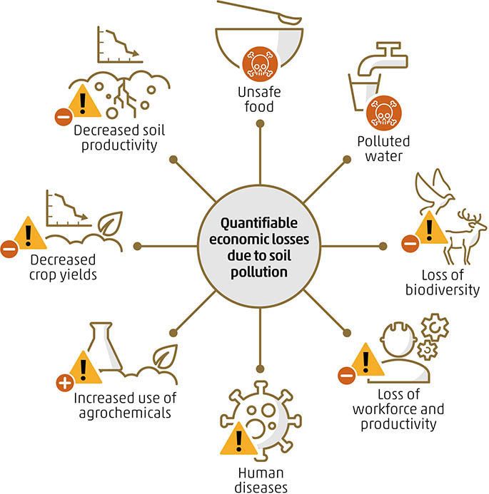

**Literature survey**

**Soil pollution impacts in earths crust**

1. IRFAN SAFI (July 2022)

#### **KOHAT UNIVERSITY OF SCIENCE AND TECNOLOGY**

Soil, the uppermost layer of the earth’s crust is a mixture of many solid, liquid and gaseous substances having both living and non-living matter such as mineral particles, decaying organic matter, microbes along with water and air contained in pore spaces. Formation of soil is a very slow process starting from weathering (Breakdown of bed rock into mineral particles) to soil development i.e., pedogenesis (modification of mineral matter through interactions between biological, topographic and climatic factors). It may take 200 to some thousand years to form an inch of topsoil depending upon the local conditions

**A specific reason for soil pollution in earth are human wastes**

1. Naiem Haque (June 2019)

Khulna University Department of Agrotechnology

The world is more connected and all the aspects of the environment are interlinked with one another more than we see with our naked eyes or even sense with our five sense organs in a given moment. It is education, which generates true knowledge about the world and the universe in our inner self. The air which we breathe every second, the water which is around 70% of the total constituents of the body, the food that we eat every day several times are very closely interrelated. In fact, it is the same energy that is revibrating through all living things, also in non-living matters. If we consider the human population, now around 7.5 billion people are living in the terrestrial part of the earth, all the economic activity, industry, living accommodation, forest, big cities are in the land area. Furthermore, the soil is getting more and more polluted due to countless artificial activities and losing its fertility. As a result, the living condition of the earth is getting down, climate change, global warming, species distinction, various health issues of humans and also other plants and animals are occurring. It is time we focus on the unseen truth of soil pollution and face the challenge to establish all the 17 SDGs successfully within 2030 with courage and hope that together both as individuals and as civilized nations of the world we can bring life back tur soils.

**Pesticides effects the soil fertility on agricultural lands**

1. Lia Matchavariani (June 2019)

Soils contaminated from water or air and by artificially applied toxic substances from pesticides, as well as mineral fertilizers, accumulate toxic elements, including heavy metals, having an extremely adverse impact on the living organisms. Among all kinds of economic activities, mining is the main source of pollution that deteriorates the agrophysical properties of soils and agroecological conditions in whole. The main ecological catastrophic zones in Georgia are discussed, related to the mining industry—Bolnisi metallogenic province (Kvemo Karli Region) and Chiatura-Zestaponi manganese province (Imereti Region). Besides, pollution of soils and water with pesticides (chlorine-organic compounds) near the former chemical warehouses is considered.

**Soil pollution by metals from mining**

1. Luma Nnaji Mohammed Tawfiq (June 2018)

Professor at University of Baghdad

In this paper the concentrations of heavy metals such: lead, chromium, nickel and cadmium, were measured in the zones of Baghdad city in Iraq thought to be deeply contaminated at depth (0-30 cm) to estimate the rate of pollution in soil. A total of 36 samples of the soil were collected from different zones such: residential, industrial, commercial, agricultural and main roads. The measurements of heavy metals got by ICP-MS technique. Then the results were compared with standard levels of these Heavy metals in the soil. A newer engineering recommended solutions are also discussed and suggested for the waste water treatment.

**Industries activities causes soil pollution**

1. Anil kumar (dec 2017)

Guru Angad Dev Veterinary and Animal Sciences University

Farm Science Centre (KVK)

Although soil is a non-renewable natural resource, human has increasingly used it as a contaminant sink since industrial Revolution. It is getting polluted in a number of ways and there is urgency in controlling the soil pollution in order to preserve the soil fertility and increase the productivity. The soil pollution occurs when amounts of some soil elements and other substances may exceed levels recommended for the health of humans, animals, or plants. Certain chemicals occurred naturally in soils as components of minerals may be toxic at certain concentration other harmful substances may end up in soils through human activities, Such as industrial activities, inadequate waste disposal, mining and by accident soil can be contaminated. Detrimental effects of contaminants on soil may be directly related to loss of biodiversity and functions such as the recycling of nutrients consequently we are losing this important natural resource by the accelerated soil pollution.

**Google survey form**



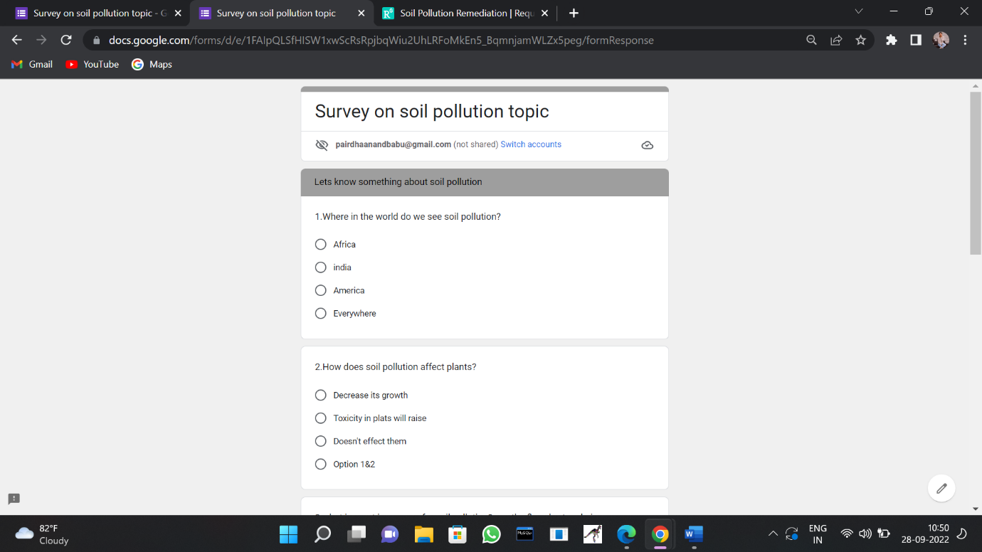





**Discussion :-** Soil pollution, a type of pollution that is being creating and increasing by human beings. It's main cause is that the human beings are throwing plastic things like polithin, plastic bags etc here and there. Some another causes are like Landfills, wastage of industries coming with water, mixing with it and being solve in the soil etc. We should know and that we are human beings, we are not animals. We should stop it as much as possible.

Soil degradationis the condition when the soil loses its minerals,nutrients or other useful chemicals needed by vegetation. This conditionmay occur due to repeated sowing of same crop without supplementing itor due to soil erosion. In case of soil degeneration the soil looses to support plant life.

**Sugesstions:-**

### **1. Plant more trees**

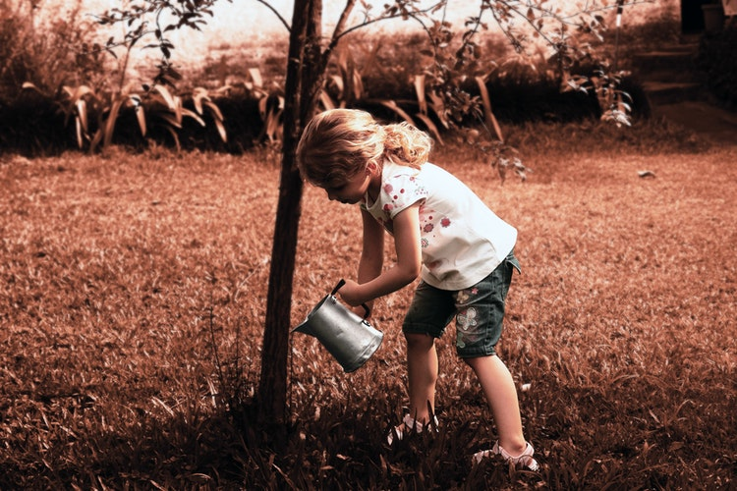

Soil erosion is activated, when there are no trees to prevent the top layer of the soil from being carried by different agents of nature like water and air.

The effects of acid rain and floods can wipe out healthy soil in the absence of trees, which would otherwise help absorb and maintain these waters and the toxins that come along. Through reforestation efforts and planting new trees and vegetation in areas that are at risk to erosion, soil pollution can be further interrupted.

### **2. Use natural alternatives to toxic substances**

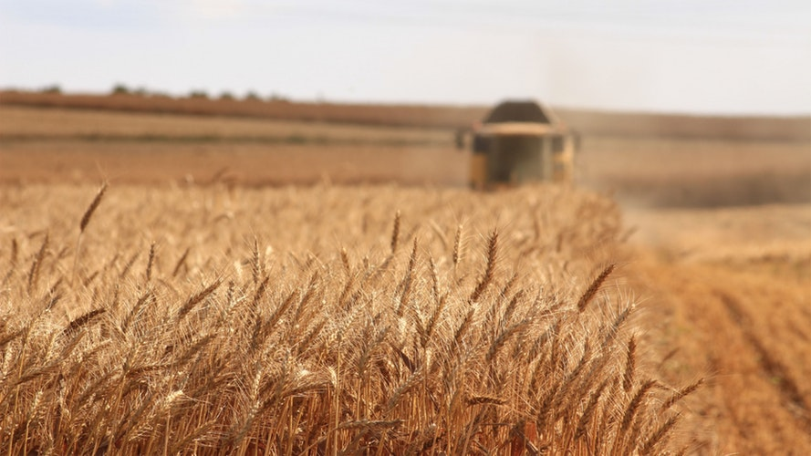

The World Health Organization estimates that over [3 million people](https://www.unenvironment.org/news-and-stories/story/tackling-growing-challenge-soil-pollution) are hospitalized due to pesticide poisoning every year, resulting in a quarter of a million premature deaths.

The pervasive use of pesticides in agricultural production can weaken and destroy the community of microorganisms living in the soil, particularly when these chemicals are overused or misused.

Current alternatives that promote sustainable agricultural practices include crop rotation, biological pest control and polyculture.

### **3. Purchase organic produce**



Buying organic products is one of the easiest ways to reduce pollution in our soil.

Sustainable agricultural production practices have become vital for overturning the trend of soil degradation and safeguarding current and future global food security. If more people buy organic products the demand for nonorganic food will decline, which means less reason and opportunity to use those fertilizers and pesticides that contribute to land pollution.

**conclusion**

In conclusion, soil pollution is an environmental issue that touches on all aspects of life. Soil pollution is causes by human activity, which can be controlled. Consequences of soil pollution are similar to those of other forms of pollution because the nature of pollutants are chemicals. Health of living things relies on a clean environment.

**REFERENCES**

1. Alkorta, I., Hernandez-Allica, J., Becerril, J.M., Amezaga, I., Albizu, I., Onaindia, M., & Garbisu, C. Chelate-Enhanced phytoremediation of soils polluted with heavy metals. Reviews in Environmental Science and Bio/Technology 3:55-70. 2004.
2. Amusan, A.A., Bada, S.B., & Salami, A.T. Effect of Traffic Density on Heavy Metal Content of Soil and Vegetation along Roadsides in Osun State, Nigeria. West African Journal of Applied Ecology 4:107-114. 2003.
3. Ayodele, J.T. & Oluyomi, C.D. Grass contamination by trace metals from road traffic. Journal of Environmental Chemistry and Ecotoxicology 3(3):60-67. 2011. Cervantes, H.F.P. An Evaluation of Metal Transport from Shoulder Highway Sections into Roadside Soils Due to Atmospheric and Runoff Processes. Ph.D. Thesis, University of British Columbia. 2005.
4. Cooper, E.M., Sims, J.T., Cunningham, S.D., Huang, J.W., & Berti, W.R. Chelate-Assisted Phytoextraction of Lead from Contaminated Soils. Journal of Environmental Quality 28(6):1709- 1719. 1999.
5. Duong, T.T.T. & Lee, B. Determining contamination level of heavy metals in road dust from busy traffic areas with different characteristics. Journal of Environmental Management 92:554-562. 2011. Epelde, L., Hernandez-Allica, J., Becerril, J.M., Blanco, F., & Garbisu, C.
6. Effects of chelates on plants and soil microbial community: Comparison of EDTA and EDDS for lead phytoextraction. Science of the Total Environment 401:21-28. 2008. Humphreys, M.O. & Nicholls, M.K. Relationship between tolerance to heavy metals in Agrostis capillaris L. (A. tenuis sibth.). New Phytol 98:177-190. 1984.
7. January, M.C., Cutright, T.J., Van Keulen, H., & Wei, R. Hydroponic phytoremediation of Cd, Cr, Ni, As, and Fe: Can Helianthus annuus hyperaccumulate multiple heavy metals? Chemosphere 70:531-537. 2008 Jaradat, Q.M. & Momani, K.A. Contamination of Roadside Soil, Plants, and Air with Heavy Metals in Jordan, A Comparative Study. Turk. J. Chem. 23:209-220. 1999.
8. Keane, B., Collier, M.H., Shann, J.R., & Rogstad, S.H. Metal content of dandelion (Taraxacum officinale) leaves in relation to soil contamination and airborne particulate matter. The Science of the Total Environment 281:63-78. 2001. Matthews, R.F. Agrostis scabra. Fire Effects Information System, U.S. Department of Agriculture Forest Service, Rocky Mountain Research Station, Fire Sciences Laboratory. 1992.